Chapter 2 Exercises
Lien Chen July 28
- How has the market share of various mortgage lenders evolved over time? Graph and discuss.

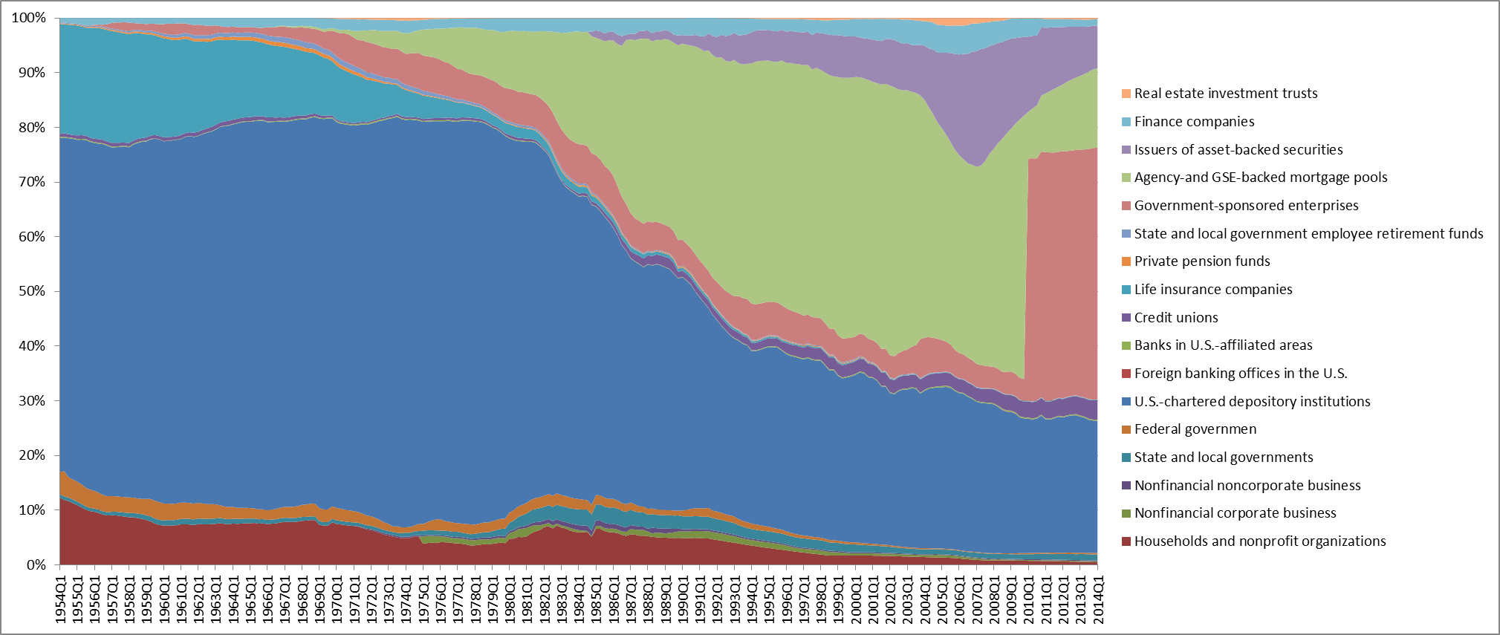
Before 1970s, 60% of the market shared was occupied by depository institutions. GSE-backed mortgage pools emerged in 1968, and sharply increased in the following 40 years. GSE pools shared an equal market share, rough 40% in the year 1990, and peaked at 50% in 2003. We can also notice that asset-backed securities, included private-label securities, bloomed during 2003 and 2008. After the financial crisis, government-sponsored enterprises take over the major amount of GSE and ABS market.

- Plot the historical spread between the “long-end” and the “short-end” of yield curve. Why is this spread such an important proxy for the health of the mortgage industry?
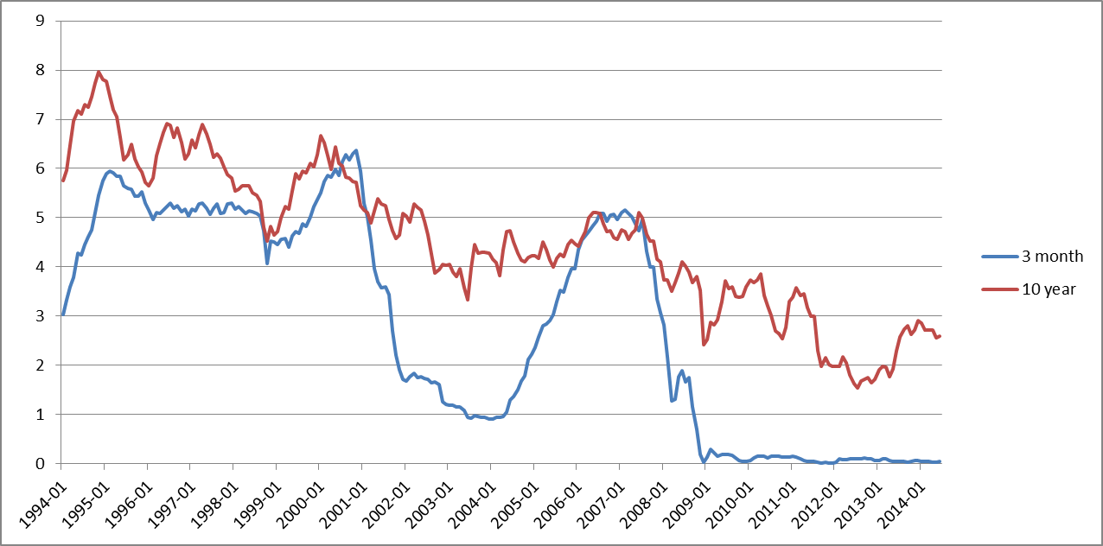
The first chart shows the time series of long end and short end yield curve. Following chart shows the spread between these two curves.
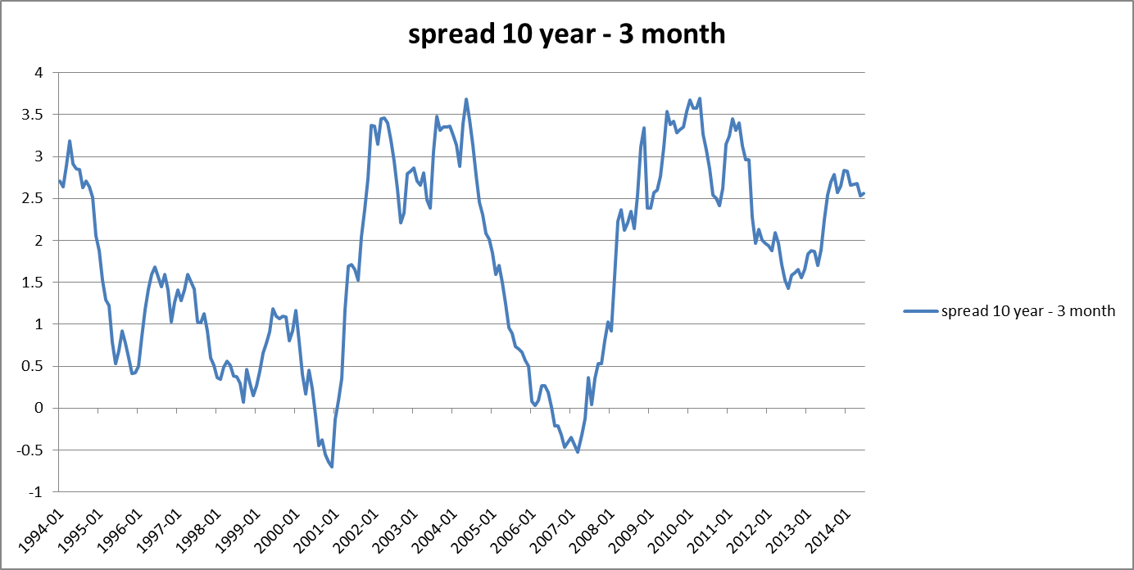
For most of the time, long term interest rate is higher than short term rate, which result in a positive spread value. However, we can see the spread goes below zero in the year 2001 and 2007. Under this situation, margin for the mortgage issuer would disappear.

- Obtain a historical time-series on credit losses experienced by residential mortgage. Why are these losses such an important indicator of the health of the mortgage industry?

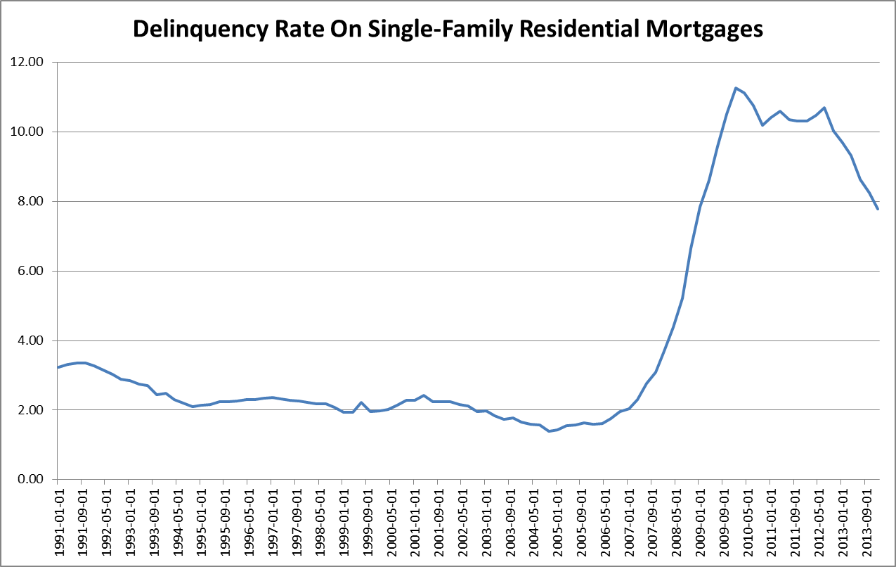
The delinquency rate for residential mortgage stays 2% to 3% before 2006. After that, the financial crisis brings a big wave of default to residential market. In the year 2009, the delinquency rate reaches 11.27% and stays high till 2009.

High delinquency rate results in high default risk, which brings a direct loss for mortgage lender. Moreover, the default activities would also bring a negative impact to the housing market, which may result in even high default rate.

- Plot the historical changes in house price using the FHFA house price series. (The FHFA has various house price series – identify which one you are using)

Using the Purchase-Only Indexes (Estimated using Sales Price Data) as the house price change series, we can see a dramatic drop after 2008. According to the percentage change of this series, the decrease started from 2005, first showed a slowdown in increase speed, then drop into negative change rate.
- What is counterparty risk and how is it different from credit risk?

Counterparty risk is the risk to each party of a contract that the counterparty will not live up to its contractual obligations. Counterparty risk in Green’s book describes a credit assault default swaps case. Since AIG did not have adequate capital to meet its contract obligation, the contract faced a default situation, and hence brings the counterparty default risk to Goldman Sachs.

Counterparty risk and credit risk both measure the default risk in mortgage market. The difference between them is counterparty risk describes the risk between a financial contract institutional counterparties. While credit risk is the risk that mortgage borrower choose to default.

- Plot the historical share of Fannie Mea and Freddie Mac versus the private-label market.

